Kerry numbered 'Real Photo' Cards.

We now come to the various 'real photo' cards produced by, or attributable to, Kerry. Some similar cards that are attributed to Trickett (but published by Kerry) are also included here. As explained in the introduction, the backs of these cards have no necessary systematic relationship to card series, but are simply a product of the print stock to hand at the time.

JKJK86 Individually numbered cards, printed in black-&-white (usually faded to sepia – and it is likely that many were originally printed in sepia toning)

JKJK87 Individually numbered cards printed as photographs and hand-coloured. In many cases, the colours have blurred, even to the extent where it is almost impossible to recognise the view. We also include here two un-numbered cards which otherwise ‘fit’here.

N.B. In series JKJK86 & JKJK87, we have incorporated the number on the card into our own number. Where the same image appears in various formats, an additional letter is used.

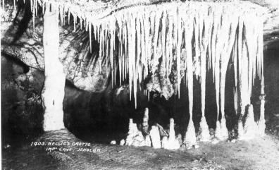  JK86.405 |  | 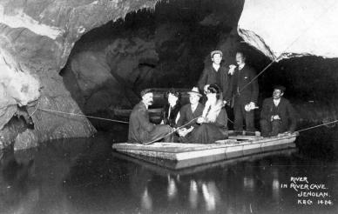  JK86.1324
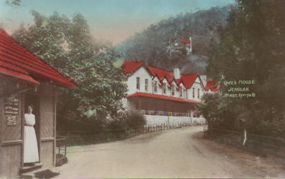  JK87.1437 |  | 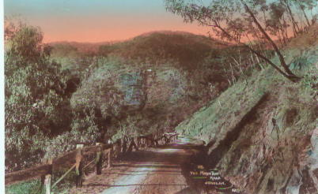  JK87.618
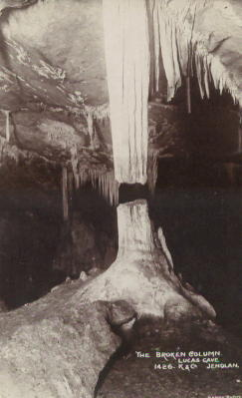  JK86.1426 | 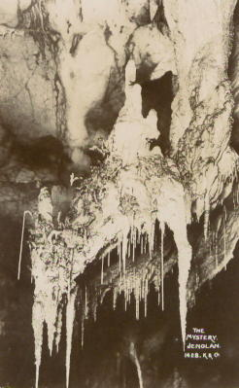  JK86.1428 |  | 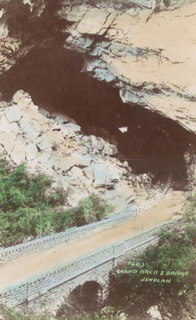  JK87.1403
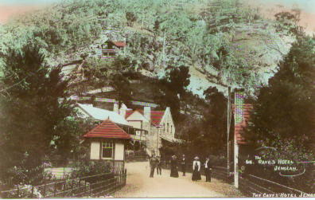  JK87.1616 |  | Some examples of the  individually numbered cards.

JK86. Kerry Individually Numbered Cards (b. & w.) [1907?]

Ph Charles Kerry
Pr & Pu Kerry & Co.
F As 'real photos' on various print papers

JK86.621 The Mountain Rd./Jenolan H K-A
The Mountain Rd./Jenolan H RP3
JK86.623 Road near/Grand Arch./Jenolan H} K-A
JK86.626 The Caves Hotel / Jenolan K-A
JK86.627 Bridge at Grand Arch V RP2
JK86.1401 Underground River, Imperial Cave H (s.n.a. 01.1) K-A
Underground River, Imperial Cave H (s.n.a. 01.1) K-D
Underground River, Imperial Cave H (s.n.a. 01.1) RP4 Underground River, Imperial Cave H (s.n.a. 01.1) ML1
JK86.1402 The Caves Hotel /Jenolan H K-D
JK86.1404 Katie's Bower/ L.I. Jenolan V (s.n.a. 00.12) RP1
JK86.1405a Nellie's Grotto/Impl Cave Jenolan H (s.n.a. 0.2) K-A
[pm.23 Jan.1908]
Nellie's Grotto/Impl Cave Jenolan H (s.n.a. 0.2) RP1
Nellie's Grotto/Impl Cave Jenolan H (s.n.a. 0.2) Empire
Nellie's Grotto/Impl Cave Jenolan H (s.n.a. 0.2) ML1
Nellie's Grotto/Impl Cave Jenolan H (s.n.a. 0.2) RP4
[pm.5 Oct.1906]
JK86.1405b Nellie's Grotto Imperial Cave, / Jenolan H (s.n.a. 0.2)K-D
JK86.1406 White Temple/River Cave Jenolan V (s.n.a. 31.10) K-A
White Temple/River Cave Jenolan V (s.n.a. 31.10) K-A
[pm. 17 Mar 1912]
White Temple/River Cave Jenolan V (s.n.a. 31.10) K-A
[ms.29 May 1917]
Sender says “Saw this afternoon - we were 3hours in the River Cave.”
JK86.1407 Gem of the West/R.I. Jenolan V (s.n.a. 00.8) K-A
[pm.23 Jul.1909]
Gem of the West/R.I. Jenolan V (s.n.a. 00.8) RP4
[pm.10 Aug.1908]
JK86.1408 The Minaret/River Cave Jenolan V (s.n.a. 00.14) RP1
[pm.15 May 1909]
The Minaret/River Cave Jenolan V (s.n.a. 00.14) K-A
SAME RP3
JK86.1409 Grand Arch West Side/Jenolan H (s.n.a. 00.7) K-D
JK86.1410 Showroom/R.I. Jenolan V (s.n.a. 1.8) K-A
Showroom/R.I. Jenolan V (s.n.a. 1.8) RP4
JK86.1411 The Great Shawl/River Cave Jenolan V (s.n.a.85.11) RP3
The Great Shawl/River Cave Jenolan V (s.n.a.85.11) K-A
The Great Shawl/River Cave Jenolan V (s.n.a.85.11) RP1
JK86.1412 Nymph's Baths/River Cave (s.n.a. 31.12) K-A
JK86.1413 Tower Chamber/River Cave H (s.n.a. 31.1) K-A
Tower Chamber/River Cave H (s.n.a. 31.1) Satrap

JK86.1414 The Proscenium/Lucas C. Jenolan V (s.n.a. 76.8) K-A
The Proscenium/Lucas C. Jenolan V (s.n.a. 76.8) RP1
The Proscenium/Lucas C. Jenolan V (s.n.a. 76.8) Boomerang
JK86.1415 Grand Stalactites/Impl Cave/Jenolan V
(s.n.a. 78.8) [pm.22 Jul.1908] ML1
Grand Stalactites/Impl Cave/Jenolan V
(s.n.a. 78.8) RP3
Grand Stalactites/Impl Cave/Jenolan V
(s.n.a. 78.8) RP4 Grand Stalactites/Impl Cave/Jenolan V
(s.n.a. 78.8) K-A
JK86.1416 Crossing Underground River / Jenolan H K-A
JK86.1417 Coral Grotto/Jenolan H (s.n.a. 00.1) K-A
Coral Grotto/Jenolan H (s.n.a. 00.1) RP3
JK86.1418 The Red Temple/River Cave Jenolan V K-A
(s.n.a. 85.12) [pm.12 Jan.1912]
The Red Temple/River Cave Jenolan V (s.n.a. 85.12) RP4
JK86.1419 Gem of the South/River C Jenolan H (s.n.a. 31.7) K-A
[pm.4 May 1909] Note this is actually in the Temple of Baal.
The photograph may well be by Trickett.
JK86.1421 Aladdin Cave/Jenolan H (s.n.a. 00.2) RP4 Aladdin Cave/Jenolan H (s.n.a. 00.2) K-A
JK86.1422 The Grand Column/River C. Jenolan V (s.n.a. 01.5) RP3
The Grand Column/River C. Jenolan V (s.n.a. 01.5) K-A
The Grand Column/River C. Jenolan V (s.n.a. 01.5) RP1
JK86.1423 Underground River/R.I. Jenolan H (s.n.a. 01.1) K-A
[pm.15 May 1909]
Underground River/R.I. Jenolan H (s.n.a. 01.1) K-D
JK86.1424 River/in River Cave/Jenolan H (s.n.a. 16.2) K-A
River/in River Cave/Jenolan H (s.n.a. 16.2) K-D
[pm.May 1909]
JK86.1425 Crystal Cities/Imperial C. Jenolan H (s.n.a. 78.11) K-A
JK86.1426 The Broken Column/Lucas Cave/Jenolan V
(s.n.a. 76.5) [pm.4 Aug.1913] K-A
The Broken Column/Lucas Cave/Jenolan V (s.n.a. 76.5) [pm. 22 Apr. 1909] K-A
The Broken Column/Lucas Cave/Jenolan V (s.n.a. 76.5) K-D
JK86.1427 Mafeking/Lucas Cave/Jenolan H K-A
JK86.1428a The Mystery/Jenolan V (s.n.a. 77.4) Satrap
JK86.1428b The/Mystery/Jenolan V (s.n.a. 77.4) RP1
The/Mystery/Jenolan V (s.n.a. 77.4) K-A

JK86.1430 The Punt/River Cave/Jenolan H [pm.15 Jan.1912] K-A
(This photo attributed to Trickett in his guide ; Snowden (in
Stanbury & Bushell, 1985 : 136) attributes it to Kerry but she also
assigns it to an 1890 date, which is obviously in error as the River Cave was not discovered until 1903. Card depicts party of ladies and
children in punt, all wearing white and said to be from the /Academy in Bathurst)
JK86.1431 Nettle Cave/Jenolan K-A
JK86.1432 Fish Hatchery / Jenolan H K-A
JK86.1434 Caves House/Jenolan V [pm.21 Feb.1910] K-A
Caves House/Jenolan V with Kerry imprint on K-D
JK86.1435 Caves House/Jenolan H K-D
JK86.1436 Carlotta Arch/Jenolan V (s.n.a. 79.8)
With Kerry imprint on K-D
JK86.1437 Caves House, Jenolan H [pm.10 Mar.1914] K-A
(A similar view to 79.1, but kiosk is closer, with woman
standing in doorway)
Caves House, Jenolan H K-D
JK86.1554 Card is titled twice :
- The/Skeleton/Skeleton Cave/Jenolan
- The Skeleton, Jenolan V (s.n.a. 13.6) K-A
JK86.1555 Oberon/Grotto/Skeleton Cave/Jenolan V K-A
(s.n.a. 31.5) [ms.18 Apr.1912]
Sender was obviously impressed with the stairways, and says “...a
wonderful sight to see. There are 10 caves. The Lucas 9JK87 steps,
The Temple of Baal 1300 steps...”
JK86.1558 “Bath of Venus" /Skeleton Cave Jenolan V K-A
(s.n.a. 31.4)
JK86.1561 Gem of Jenolan/Jubilee Cave/Jenolan V K-A
(s.n.a. 0.6)
JK86.1562 Stag Horns/Jubilee Cave/Jenolan V (s.n.a. 80.2) K-A
JK86.1563 The Curios/Jubilee Cave/Jenolan H (s.n.a. 00.4) K-A
JK86.1566 Alabaster Hall/Jubilee/Cave/Jenolan H K-A
JK86.1567 Gem of the South" /Temple of Baal /Jenolan V K-A
Gem of the South" /Temple of Baal /Jenolan V
` [ms.30 May 1917] K-D
JK86.1568 Shawls/Temple of/Baal/Jenolan V (s.n.a. 84.4) K-A
JK86.1569 Dragons Den/Temple of Baal/Jenolan V K-A
(s.n.a. 84.2)
JK86.1570 Gem of the South/Temple of Baal/Jenolan V Satrap
(s.n.a. 31.7)
Gem of the South/Temple of Baal/Jenolan V K-A
(s.n.a. 31.7)
JK86.1571 The Altar / Temple of Baal / Jenolan H K-A
[ms.30 May 1917]
JK86.1572 The Mysteries/Temple of Baal/Jenolan V K-A
[ms.30 May 1917]

JK86.1573 The/Furze Bush/River Cave/Jenolan V (s.n.a. 85.6) Satrap
The/Furze Bush/River Cave/Jenolan V (s.n.a. 85.6)
[ms.29 May 1917] K-A
JK86.1576 Niagara/River Cave/Jenolan V (s.n.a. 85.7) K-A
JK86.1578 "The/Mops"/River/Cave/Jenolan H (s.n.a. 85.1) K-A
JK86.1579 Crystal Palace/Right Imperial/Jenolan V (s.n.a. 0.1) K-A
[pm.23 Jul.1909]
Crystal Palace/Right Imperial/Jenolan V (s.n.a. 0.1) Satrap
JK86.1580 Gem of the West/Right Imperial/Jenolan V K-A
(s.n.a. 00.16)
JK86.1581 Josephine/Grotto/Right Imperial/Jenolan V K-A
JK86.1582 Card is titled twice :
- Shawls Imperial Cave Jenolan
- Shawls/Right Imperial Jenolan
V, with wide white margins at top and bottom K-A
(s.n.a. 78.5)
JK86.1582 Shawls/Right Imperial Jenolan V (s.n.a. 78.5) K-A
  - Wilkinson Cave/Left Imperial/Jenolan H
(s.n.a. 78.3) K-A
JK86.1590a The Curtain/Lucas Cave/Jenolan V (s.n.a. 76.10) K-A
JK86.1590b Card is numbered and titled twice K-AA
The Curtain, Lucas Cave, Jenolan V
also 3279, same title (s.n.a. 76.10)

Card is numbered and titled twice
The Curtain, Lucas Cave, Jenolan V
also 3279, same title (s.n.a. 76.10) K-D
JK86.1591 Crystal/Fountain./Lucas Cave./Jenolan. V K-A
(s.n.a. 7.6) [pm.25 May 1910]
JK86.1592 Coral Grotto/Lucas Cave, Jenolan H K-A
[pm.15 Mar.1910] This is s.n.a. 77.10, which correctly
locates it in the Left Imperial.
JK86.1595 Lyre Birds Nest/Orient Cave/Jenolan K-A
card is titled twice
JK86.16JK86 Granny's Shawl,Orient Cave, Jenolan V K-A
(s.n.a. 83.11)
JK86.1691 Grand Arch/West Side H ML1
JK86.3262 Grand Arch/West Side H K-D
JK86.3279 see above under JK86.1590b
JK86.4326 The Willows, Nettle Cave V (s.n.a. 81.4) K-A
JK86.4327 (The Ballroom, Nettle Cave) H (s.n.a. 81.2) K-A
JK86.4329 Entrance to Nettle Cave, Devil's Coach House V K-A
JK86.4330 The Sanctuary, Nettle Cave, Jenolan V K-A
JK86.4332 Sculptor's Studio, Nettle Cave, Jenolan V
(s.n.a. 81.6)

JK87. Kerry Individually Numbered Cards (Hand-Coloured) [1907?]

Ph Charles Kerry
Pu Kerry & Co.
Pr as 'real photos' on various print papers

The actual colouring was done using transparent dyes and an artists’ brush. One of the colorists was Pearl Wilson, daughter of Frederick.

JK87.612 The/Grand Arch/Jenolan V K-A
The/Grand Arch/Jenolan V [ms.25 May 1908] RP1
JK87.613 Carlotta Arch/Jenolan V (view from below) RP1
Carlotta Arch/Jenolan V (view from below)
(with Kerry imprint on back) RP2
Carlotta Arch/Jenolan V (view from below) K-A
Carlotta Arch/Jenolan V (view from below) K-D
JK87.614 Grand Arch/Jenolan H (s.n.a. 00.7) K-A
[pm.13 Dec. 1911]
Grand Arch/Jenolan H [pm.27 Jan.1914] K-AA
Grand Arch/Jenolan H RP1
Grand Arch/Jenolan H (with Kerry imprint on back) RP2
JK87.615 Devil's Coach/House/Jenolan V (s.n.a. 00.10) K-A
[pm.17 Sep.1910]
Devil's Coach/House/Jenolan V RP4
Devil's Coach/House/Jenolan V [pm.30 Mar.1907] RP2
Devil's Coach/House/Jenolan V [pm.17 May 1907] RP2
Although not related specifically to the caves, this card has one of the
more interesting backs we have seen. The sender has glued to the card a poem, apparently cut from a magazine :

(To be sung to the tune of "Violets")
Every day I send thee postcards,
Which for pennies I have bought,
Just to fill your wretched album ;
I've no time for other thought.

I've no time to climb the mountains,
Visit churches, see the sights,
All the days I hunt thee postcards,
Which I post to thee at nights.

Knows't thou what these horrid pictures
Could they speak for me, would say ?
They would wish for thee, the nightmare
They have been to me by day.

JK87.616a Card is titled twice:
- The/Caves Hotel/Jenolan
- The Caves Hotel, Jenolan H RP3
Shows view from driveway with six visitors in foreground.
JK87.616b The/Caves Hotel/Jenolan H RP2
The/Caves Hotel/Jenolan H RP4
JK87.617a The/Caves Hotel/Jenolan (view from above) H K-A
The/Caves Hotel/Jenolan (view from above) RP4
JK87.617b The/Caves Hotel/Jenolan (view from above)
Card is titled and numbered twice:
- The/Caves Hotel/Jenolan
- The Caves Hotel, Jenolan 2688 H RP2
Shows view from roadway uphill of house [pm.9 Sep.1907]
JK87.617B (The Grand Arch) H K-A
'GREETINGS FROM JENOLAN' superimposed in
ornate type. (s.n.a. 79.2)
Note : this card actually numbered with letter B
JK87.618 The Mountain/Road/Jenolan H K-A
The Mountain/Road/Jenolan H
[pm. In UK 5 Feb 1906] RP2
JK87.619a The/Bathing Pool/Jenolan V [ms. Apr 1907] RP1
The/Bathing Pool/Jenolan V RP2
JK87.619b Card is titled and numbered twice:
- The Bathing Pool, Jenolan
- 3317 The Bathing Pool, Jenolan V K-A
Do. RP2
Do. ML
JK87.619B (The Grand Arch) V RP2
'GREETINGS FROM JENOLAN' superimposed in
ornate type. (s.n.a. JK87.612)
'GREETINGS FROM JENOLAN' superimposed in
ornate type. (s.n.a. JK87.612) K-A
Note : this card is actually numbered with letter B
JK87.620 The Caves Hotel/Jenolan H [pm.20 Nov.1907] RP2
JK87.621 The Mountain Rd./Jenolan H K-A
The Mountain Rd./Jenolan H RP4
JK87.623 Road near/Grand Arch/Jenolan H K-A
(Actually shows bridge as seen from near Arch)
JK87.624 The Cascade/Jenolan RP2
JK87.625 Under the/Grand Arch/Jenolan V K-A
Under the/Grand Arch/Jenolan V
(with Kerry imprint) RP2
(View from stream level, showing bridge from below)
JK87.626 The Caves Hotel/Jenolan H [pm.2 Jan.1909] K-A
JK87.628 Devil's Coach House/Jenolan V K-A
Devil's Coach House/Jenolan V RP2
JK87.629 Carlotta Arch, Jenolan V [pm.2 Jan.1909] K-A
Carlotta Arch, Jenolan V RP2
(View from above)
JK87.630a The Caves Hotel/Jenolan H [pm.21 Mar.1907] RP2
The Caves Hotel/Jenolan H [ms.8.Jul 1907] RP2
The Caves Hotel/Jenolan H [pm.25 May 1905] RP1
(This card shows view from the hillside above the house.)
JK87.630b Card is numbered and titled twice :
- Caves House/Jenolan
- Caves House/Jenolan 1435 H (s.n.a. 79.1) K-A
[pm.7 Jul.1909]
See also separate cards under JK87.1435
JK87.633 Card is numbered and titled twice:
- Caves House/Jenolan
- Caves House,/Jenolan 1437 H (s.n.a. JK86.1437) K-A
JK87.716 The Cascade, Jenolan H RP2
[Our copy has 'J.P.T.' superimposed in tinsel - doubtless
a personal addition - the card is addressed to a Mr.
Trenwith.]
JK87.1402 The Caves Hotel/Jenolan H RP1
The Caves Hotel/Jenolan H ML1
JK87.1403a Grand Arch & Bridge/Jenolan V (s.n.a 00.13) K-A
(Serial number above title)
JK87.1403b Grand Arch & Bridge/Jenolan V (s.n.a. 00.13) K-A
Grand Arch & Bridge/Jenolan V (s.n.a. 00.13) K-D
(Serial number below title)
JK87.1409 Grand Arch West Side/Jenolan H (s.n.a. 00.7) K-A
JK87.1432 Fish Hatchery/Jenolan H [pm.29 Dec.1908] K-A
JK87.1434 Caves House/Jenolan V (s.n.a. JK86.1434) K-A
Caves House/Jenolan V (s.n.a. JK86.1434)
[pm.4 Nov.1913] K-AA
Sender says '... One of Nature's Wonderlands - a
great emporium - from diamonds and bridal veils to
shoulders of mutton and poultry.' Is she serious or
just laughing at the guides ?
Caves House/Jenolan V (s.n.a. JK86.1434)
[ms.30 Dec.1915] ML1
This sender is more interested in her accomodation
than the caves and says, '...One feature of the place
is the lovely baths. I have a hot one each night...
Mt. Victoria Hotel was most sumptuous. I have never
been in one like it before. The dining-room walls
were all upholstered and such rich carpets on the
floor...'
Another says ‘. . . Motored from Sydney 6.30 a.m., arrived 2.30 p.m.’
Caves House/Jenolan V (s.n.a. JK86.1434) K-D
Caves House/Jenolan V (s.n.a. JK86.1434) RP5

JK87.1435 Caves House/Jenolan H (s.n.a. 79.1) K-A
[ms.24 Apr.1911]
Caves House/Jenolan H (s.n.a. 79.1) K-D
Caves House/Jenolan H (s.n.a. 79.1) with Kerry imprint on K-D
Caves House/Jenolan H (s.n.a. 79.1) ML1
Caves House/Jenolan H (s.n.a. 79.1) RP5
JK87.1436 Carlotta Arch/Jenolan V (s.n.a. 79.8) K-A
[pm. 26 June 1909]
Carlotta Arch/Jenolan V (s.n.a. 79.8)
[pm.30 Nov.1914] ML1
JK87.1437 Caves House/Jenolan H (s.n.a. JK86.1437) K-A
[pm.30 Dec.1911] (also numbered 633)
Sender William writes 'Dear Mother - I arrived at Mt.
Vic. about half past 4 in the late train, camped at
Cocke's (sic) Creek and got to Cooke's Friday.'
(Note: probably refers to Ted Cooke, proprietor of
Kia-Ora Guest House)
Caves House/Jenolan H (also numbered 633) K-A
Caves House/Jenolan H [ms.24 Feb.1915] ML1
Caves House/Jenolan H ML1
(Card has pencilled listing of caves with names of speleothems
and various measurements)
See also JK87.633
JK87.1691 Grand Arch/West Side H (s.n.a. 79.2) ML1
JK87.2688 See 18.617 above
JK87.3317 See 18.619 above

JK87.xx Jenolan River (s.n.a. 79.5) ML1
JK87.xx [Looking out from Grand Arch] Jenolan Caves H RP2
JK87xx On the Road to/ Jenolan Caves/ N.S.W.H RP2
These cards have the appearance of this series, but no title or number is visible (faded?).

